Joint Resource Allocation and Trajectory Optimization for Multi-UAV-Assisted Multi-Access Mobile Edge Computing

IOT are small devices which sense data from it nearby environment and report to centralized server from further processing and this IOT can be anything like smart phones, sensors or any other devices which runs on battery and perform communication using internet. Due to limited battery this IOT cannot perform heavy computation task and need to offload this heavy computation task to nearby Mobile Edge Computing networks, if this edge network far away then IOT cannot offload task to edge servers. To overcome from this issue UAV (Unmanned aerial vehicle) was introduced which moves on fixed altitude nearer to IOT locations so IOT can easily offload to nearby UAV to get processed result.

All existing techniques were using SINGLE ACCESS UAV where all IOT will send or offload task to single UAV which leads to more energy consumption and get more delay in response.

To overcome from above issue author of this paper employing Multi UAV Assisted Mobile Edge Access where single IOT can offload task between multiple UAV and those UAV will process task and send result back to IOT. Here by diving task between multiple UAV and selecting only those UAV which are free for communication can reduce energy consumption and can get response faster.

In propose multi-UAV-assisted multi-access MEC model by allowing each IoT user to offload task bits to multiple MEC servers deployed at UAVs simultaneously for parallel computing, which can effectively reduce the energy consumption of users and UAVs. The weighted sum energy consumption of UAVs and users is minimized by jointly optimizing the bit allocation, transmit power, CPU frequency, bandwidth allocation and UAVs’ trajectories. Due to the non-convexity of the formulated problem, it is decomposed into two sub-problems and a joint resource allocation and trajectory design algorithm is proposed by alternative optimization.

Following modules are used to offload task

1. Communication Model: using this module vector will be created with values 0 and 1 and if user offloading task then vector will be filled with 1 else 0 and by using this vector system can know communication load on each UAV
2. Computation: to ensure all user/IOT task must be computed so Mobile EDGE CPU frequency will be assigned to each IOT request
3. UAV Model: using this module UAV will move from fixed altitude location and by using this locations IOT will find nearer UAV for task offloading
4. Joint Resource Allocation and Trajectory Optimization: Based on vector of load the resource will be jointly allocated between multiple UAV’S. Each IOT will optimized UAV trajectory (movement) by analysing vector load.

To implement this project we have designed IOT UAV simulation which consists of following modules

1. Generate IoT Network: using this module we will create virtual IOT and UAV devices. Each UAV will move from its location to another location to receive offload request from IOT devices
2. IoT Task Offloading: using this module we can select any IOT which will offload task to multiple nearby UAV’S which will process request and send result back to IOT. For each request energy consumption will be calculated based on single and multiple UAV access
3. Energy Graph: using this module we will plot energy consumption graph between existing single UAV access and propose multiple UAV access.

SCREEN SHOTS

To run project double click on ‘run.bat’ file to get below screen

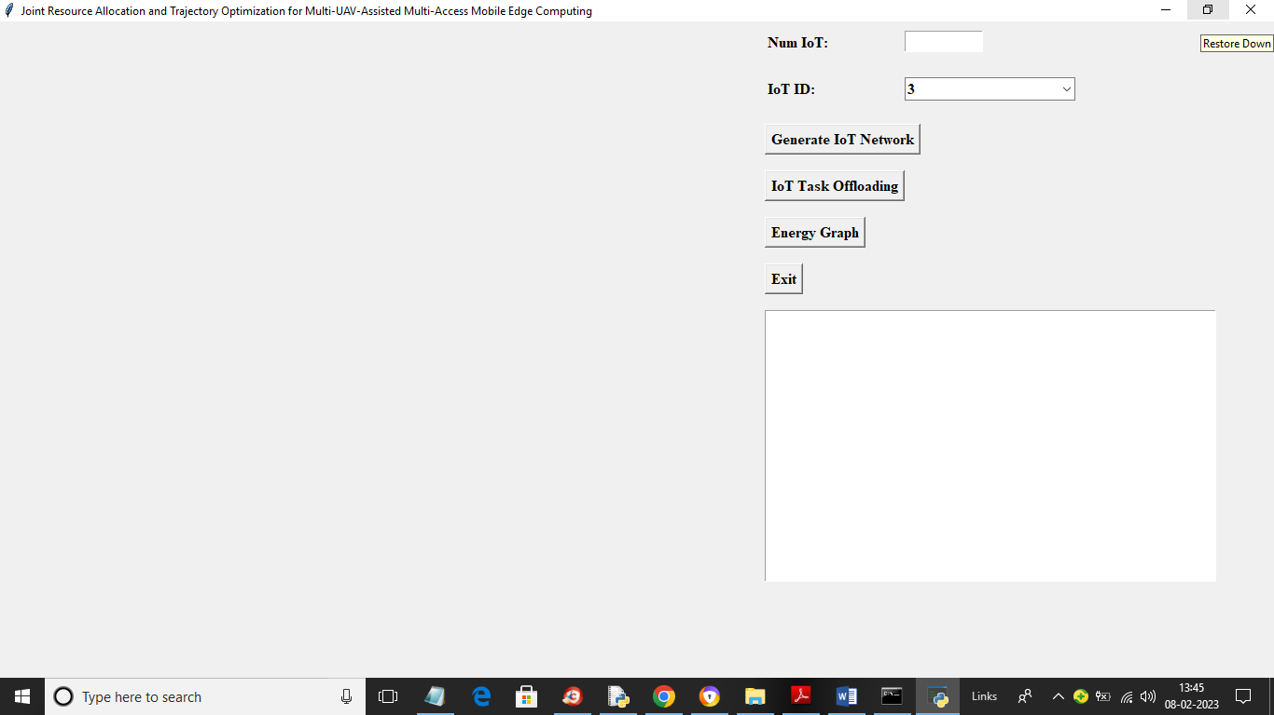

In above screen in first text field enter number of IOT and then press ‘Generate IOT Network’ button to get below output

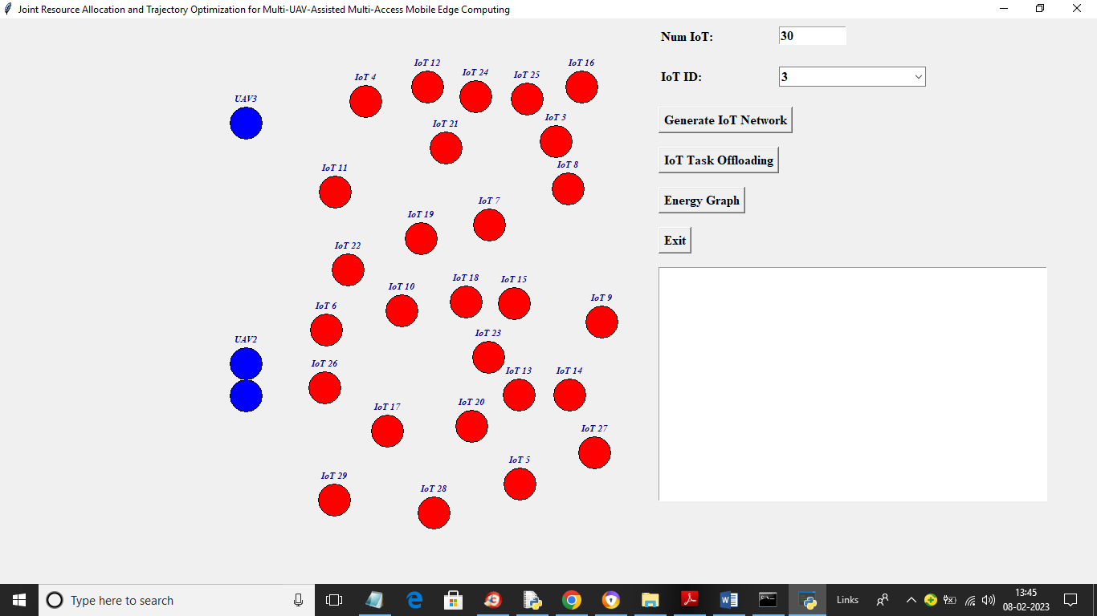

In above screen I entered number of IOT as 30 and after pressing ‘Generate IOT Network’ we got above output where red colour nodes are the IOT and blue colour nodes are the UAV and we can see UAV are moving which we can see in below screen

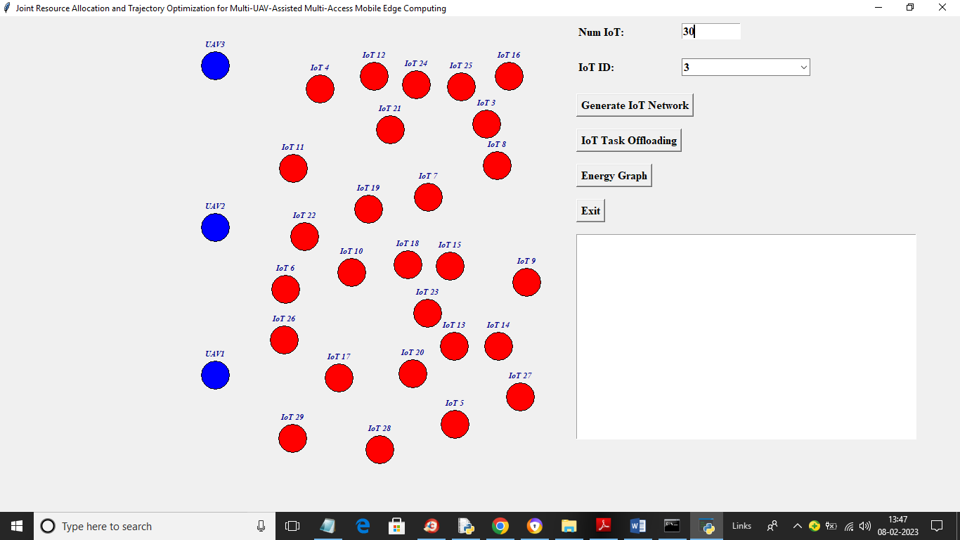

In above screen we can see blue UAV are moving and now from drop down box select any IOT ID and press ‘IOT Task Offloading’ button to offload task and get below output

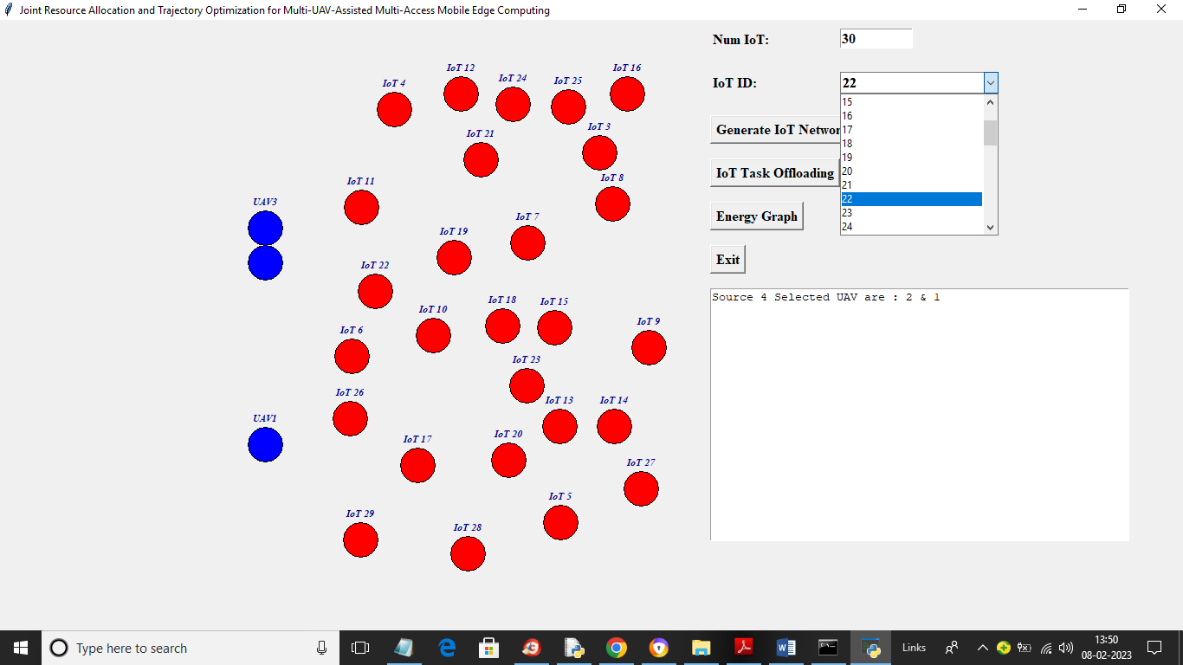

In above screen I selected IOT as 22 and then press ‘Offload’ button to get below output

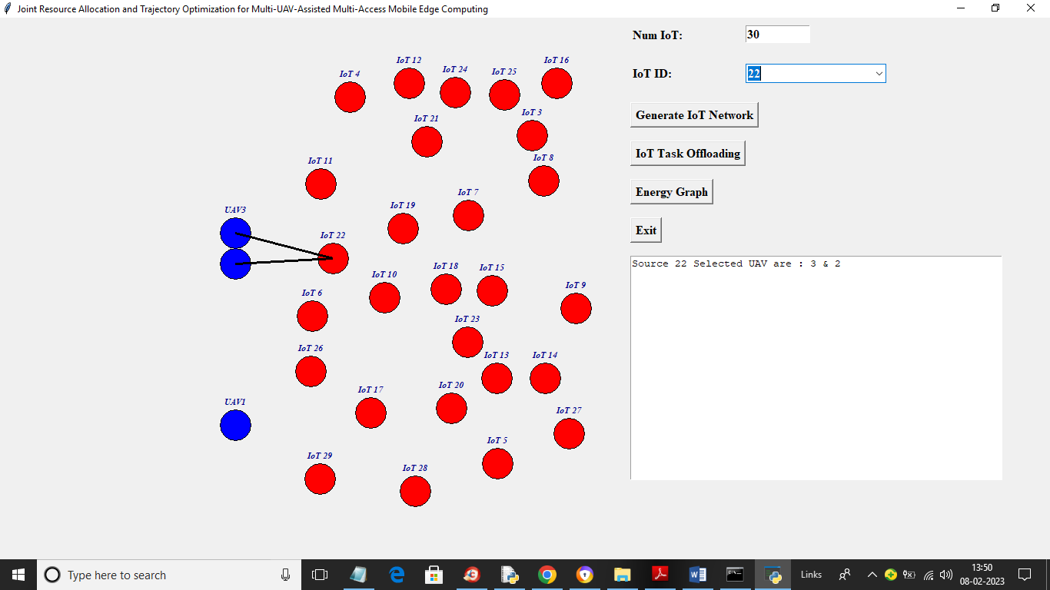

In above screen we can see IOT22 offloading task between two UAV 3 and 2 and similarly you can select any IOT and offload task to UAV

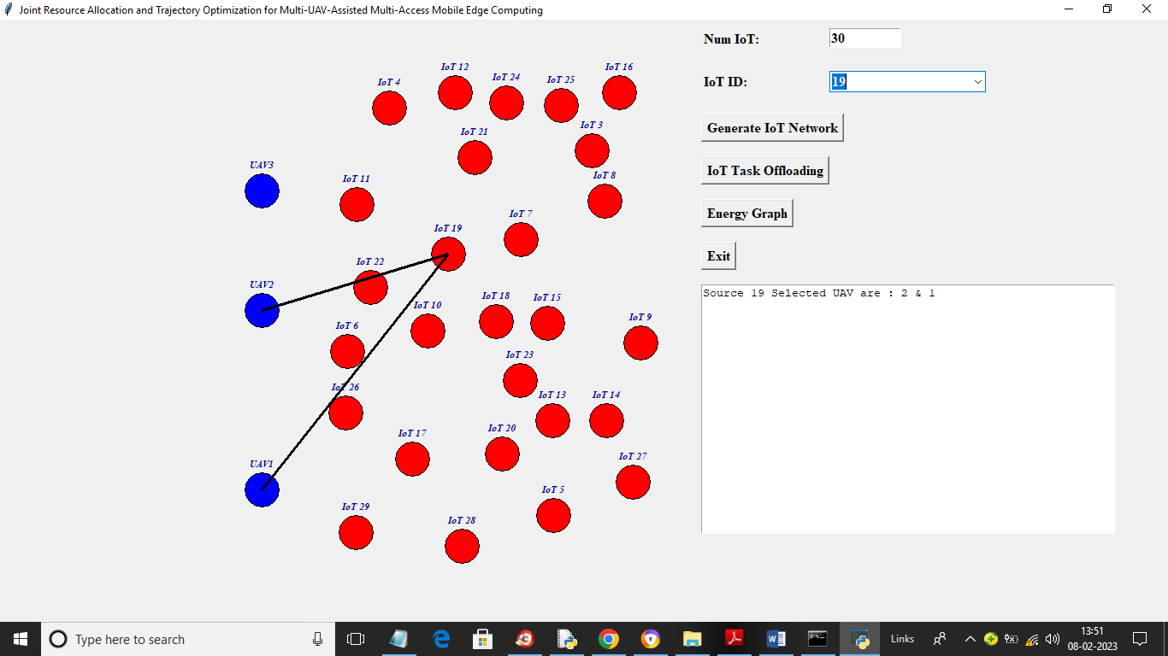

In above screen we can see another IOT offloading task to multiple UAV and offloading can be known by seeing black connecting line

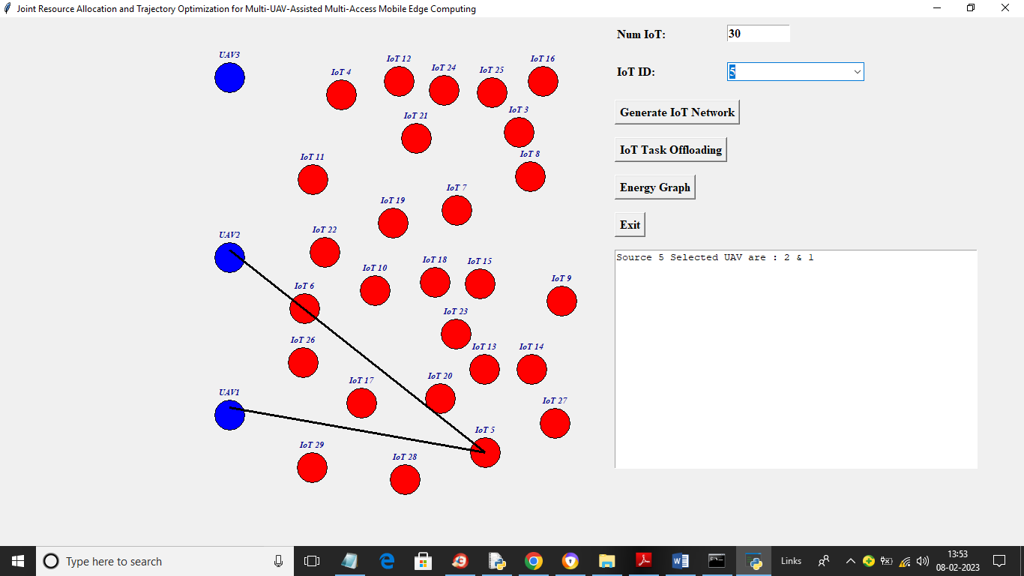

In above screen we can see IOT 5 is offloading to nearer UAV and now click on ‘Energy Consumption Graph’ button to get below graph

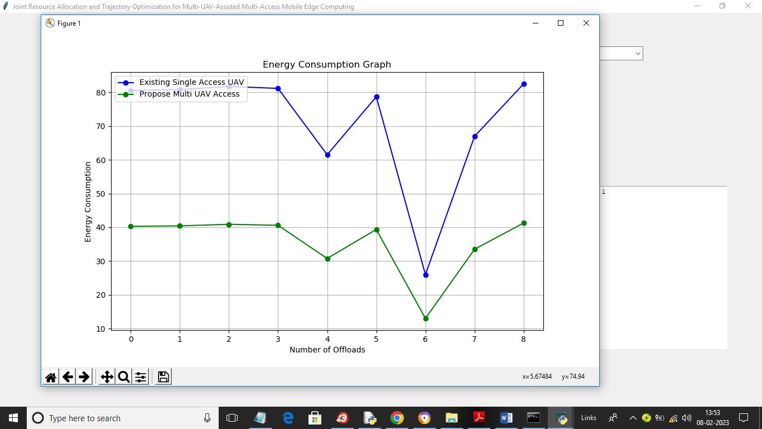

In above graph x-axis represents number of task offload and y-axis represents energy consumption where blue line represents existing single access UAV energy consumption and green line represents propose multi access UAV energy consumption and in both techniques propose is taking less energy consumption compare to existing.